Examples of Groups funded in the last
New Beginnings Round

These groups received a grant of between £9000 and £10,000

Groups working with Refugee and Asylum Seeker Children

Home Start Dover
home-startdoverdistrict.org.uk
The New Beginnings fund will help parents in Dover to support asylum seekers and refugee parents and young children.
Home-Start is a charity that makes local connections. Home-Start ‘match’ experienced parents with newer parents. The experienced parent supports the newer parent with tasks and friendly advice. They are volunteers.
New Beginnings funding will enable refugees and asylum seekers to join activities like family groups, holidays and healthy eating events. Refugees and asylum seekers will receive assistance with forms, finances and travel. Like all Home-Start families they have access to emergency funds.
Dover families will participate in activities together with asylum seekers and refugees. The aim is to help people feel less lonely and to understand and accept each other. Home-Start helps people build support networks of friends.
Home-Start Dover estimate that 30 people will benefit from the grant.

Note: Home-Start Dover is an independent local charity that is a member of the Home-Start federation.
New Beginnings cannot fund national charities unless there is a strong local connection.

Whiterock Children’s Centre
whiterockchildrenscentre.org
New Beginnings funding means refugees and asylum seekers can volunteer in West Belfast. The fund will help children and parents at the same time. It will pay for travel and childcare expenses so parents can volunteer. Parents will take part in programmes designed to break down barriers and build relationships. Residents will socialise with each other. Asylum seekers / refugee children will have additional opportunities to play, learn and socialise with children from local communities within West Belfast. Asylum seekers and refugee families will feel less isolated and safer within the communities that they live in.
The Children’s Centre has seen increased demand for services and the need for new kinds of services. This funding will also help co-ordination of services in West Belfast and highlight what is needed across different agencies.
Whiterock estimate that 115 people will benefit from the grant.

Whiterock Children’s Centre is a charity.

Projects working with Adults and Young People

The Bike Project
www.thebikeproject.co.uk

New Beginnings funding will pay for refugees and asylum seekers to have cycle training and meet Londoners who have lived here all their lives and other newer arrivals.

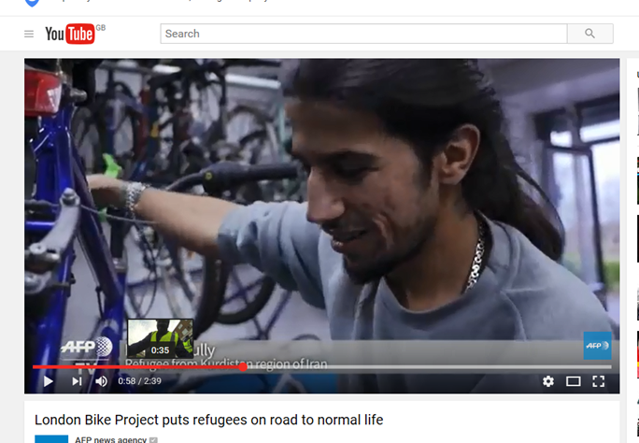
The Bike Project receives donations of abandoned bikes. They work with refugees and asylum seekers to mend and service the bikes. They then donate a bike, along with lights, helmet and lock, to a refugee/ asylum seeker. The bikes help refugees and asylum seekers travel up to 40 miles an day to access essential services like English lessons. This saves them money and provides new skills and friendships. Many return as volunteers, enjoying the work and the company.

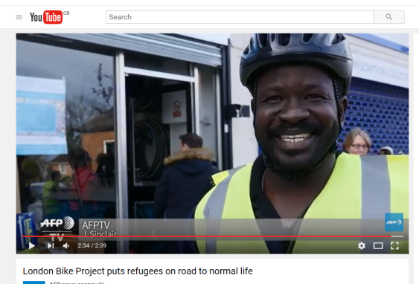
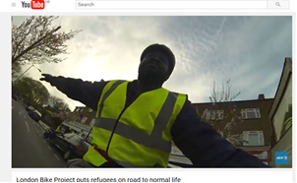

"It's like I have new wings," says Sudanese asylum seeker Maizer Ramadan.

The Bike Project have made two films about the project:
https://youtu.be/QyegoyPzoIU https://youtu.be/6W9zVLu_Dus
The Bike Project estimate that 1000 people will benefit with 30 volunteers benefitting.

The Bike Project is a registered charity and a company.
They sell bikes to the public as well as donating them to refugees.

Maryhill Integration Network (MIN)
www.maryhillintegration.org.uk
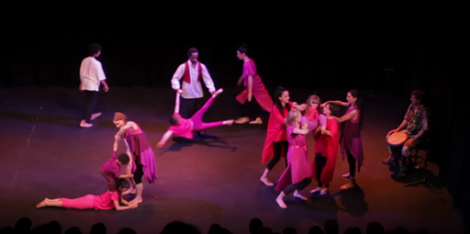
New Beginnings will help this award winning charity continue to involve refugees and asylum seekers in the arts in Scotland.
Anna came to Glasgow in 2005, after fleeing the oppressive regime in Iran. She came from a liberal family who believed in the value of the arts, especially traditional dance. In Iran, Anna’s mother found an illegal dance class for her to attend, however it became too dangerous so they fled. In Glasgow, Anna felt homesick and lonely. After joining MIN she found friends and was able to dance and perform as part of the Dance Project and International Fashion Show.
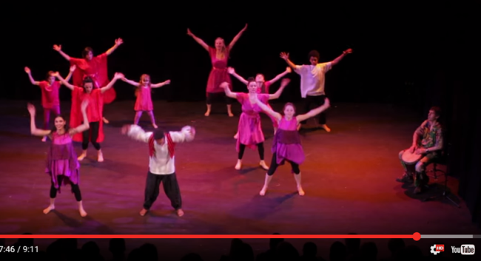
“MIN gave me the chance to show my culture to other people, the dance group is unique and I love it. We show people, through dance, why refugees have to leave their countries. Refugees need to find ways to express themselves and share the beauty of their culture, as well as learning about Scottish culture. I feel so lucky to be part of MIN, to share dances and costumes from my country, it is my voice and experiences, but also that of so many other Iranian women.”
Anastasia from Scotland is a volunteer. “I feel the work that MIN do is so important to our society, working for the community at grassroots level, which is fundamental to building community relationships, integrating the people that come here as refugees and for the community as a whole. It has been a very empowering, healing experience for me; it feels like belonging to a family, and would leave a great void in my life if it wasn't there.”

Maryhill Integration Network estimate that 692 people will benefit from the funding.

Maryhill Integration Network is a charity and independently constituted unincorporated voluntary organisation based in Glasgow.

A Partnership Project

Unity in Diversity and Swansea Bay Asylum Seekers Support Group https://sbassg.wordpress.com/ https://uidswansea.com/

This project received £20,000

New Beginnings will help this partnership expand. It will pay for a waged worker for these groups that have relied on volunteers until now.
Numbers of asylum seekers in Swansea are growing: from around 600 accommodation places at the start of 2015, Swansea now has around 1000 places. More of the people are badly traumatised. Many are unaccompanied young men, in large national, ethnically conflicted groups. There are more destitute refused asylum seekers and destitute refugees.
The funding will pay for education and training, social and cultural events, advice, signposting, and impact monitoring. The funding means the groups can accept more local people wishing to volunteer and can train more volunteers. Asylum-seekers and refugees are not just learners, or service users. They will help maintain and update a directory of services. This will help other groups and agencies refer people to the existing available services. These changes will help the groups be more sustainable.
The partnership estimate 600 people will benefit from this work.

Unity in Diversity and Swansea Bay Asylum Seekers Support Group are both registered charities.

